**APPENDIX 1**  
  
**E-LEARNING PLATFORM MANAGEMENT   
  
A PROJECT REPORT**

***Submitted by***

**BOLLINENI NARASIMHA NAIDU (723921244011)**

**KUNCHAM VENKATA RAMANA REDDY (723921244026)**

**SURA VENKATA SUBBARAYUDU (723921244047)**

**THAMMIENI VAMSI KRISHNA (723921244048)**

***in partial fulfillment for the award of the degree*  
 *of***

**BACHELOR OF TECHNOLOGY   
*in***

**COMPUTER SCIENCE AND BUSINESS SYSTEMS**

 **ARJUN COLLEGE OF TECHNOLOGY**

**COIMBATORE - 642 120**

**ANNA UNIVERSITY: CHENNAI 600 025**

**MAY 2025**

**APPENDIX 2**

**ANNA UNIVERSITY: CHENNAI 600025**

**BONAFIDE CERTIFICATE**

Certified that this project report “E-Learning platform Management” is the bonafide work of **“………………………………………………………………………………………………………………………………………………………………………………………………………………………………………………………………………………**” who carried out the project work under my supervision.

SIGNATURE SIGNATURE

**Mr. SUGAVANAM.S** **Mrs.JANANI.K**

**Head of the Department SUPERVISOR**

Department of CS&BS**,** **Assistant Professor**

Arjun College Of Technology, Department of CS&BS,

Coimbatore -642 120 Arjun college of Technology,

Coimbatore -642 120

Submitted for the Anna University Project Viva-Voce held on______________

INTERNAL EXAMINER EXTERNAL EXAMINER

**APPENDIX 3**

**ACKNOWLEDEMENT**

We owe our sincere and heartfelt thanks to our chairman **Thiru. R. SURIYANARAYANAN,** and also, we extend our profound thanks to our Secretary **Dr. R. SURESH KUMAR M.E., Ph.D.,** for their exuberance in motivating young minds.

Our deepest gratitude and thanks to our motivator and Principal Dr. **N. JANAKI MANOHAR M.E., Ph.D.,** who always helping us whenever we approach him during the course of our project.

We would also like to express our profound thanks to our Head of the Department **Mr. SUGAVANAM. S, Associate Professor,** Department of Computer Science and Business Systems, whose thoughtful words, advise and help to complete our project successfully.

We would also like to express our profound thanks to our Project Coordinator and guide **Mrs.JANANI. K, Assistant Professor, Department** of CS&BS whose thoughtful words, advise and help to complete our project successfully.

We express our sincere thanks to all **Faculty Members and Skilled Assistants** of Computer Science and Engineering Department and our lovable friends for their help and wishes for the successful completion of this project.

Finally, yet importantly, we would like to express our indebtedness to our beloved **parents** for their affectionate blessing co-operation at all stages of this academic venture and also our well-wishers.

**APPENDIX 3**

**TABLE OF CONTENTS**

**Contents : Page No :**

**I. ABSTRACT VI**

**1.Introduction 01**

1.1 Background and motivation

1.2 objectives for the project

1.3 Scope of the Platform

**2.Literature Review 02**

2.1 Overview of E-Learning Platform

2.2 Comparison with Existing solutions

2.3 Advantages of using Django and Python

**3. System Analysis and Design 08**

3.1 Requirements Gathering

3.2 Functional and Non-Functional Requirements

3.3 System Architecture

3.4 Database Design

3.5 User Interface Design

**4.Implementation 15**

4.1 Technology Stack

4.2 Backend Development (Django)

4.3 Frontend Development

4.4 User Authentication and Authorization

4.5 Course and Content Management

**5.Features and Functionalities 23**

5.1Course Management

5.2 User Management (Students & Educators)

5.3Assignment and Quiz Creation

**6.Testing and Evaluation 27**

6.1 Test plan and Strategy

6.2 Unit Testing and Integration Testing

6.3 User Acceptance Testing

**7. Security and performance Considerations 31**

7.1 Data security Measures

7.2 Performance optimization

7.3 Scalability and Future Enhancements

**8. Conclusion and Future Work 34**

8.1 Summary of Achievements

8.2 Limitations

**9.Refernace 36**

**10.Output 37**

**List of Figures:** **Page No :**

**Fig.No: 1** Overview of E-Learning Platform **03**

**Fig.No: 2** Block Diagram **06**

**Fig.No: 3** User Authentication and Authorization  **19**

**Fig.No: 4** Course and Content Management **22**

**Fig.No: 5** Assignment and Quiz Creation **26**

**Fig.No: 6** User Acceptance Testing **30**

**Fig.No: 7** Conclusion and Future Work **35**

**ABSTRACT**

E-Learning Platform using Django and Python is a comprehensive web application designed to facilitate online education and provide a robust learning environment for students and educators. Built on Django's powerful framework, the platform offers a wide range of features to support interactive learning, course management, and student engagement. The application enables educators to create and manage courses, upload learning materials, and design interactive assignments and quizzes. Students can access course content, participate in discussions, and track their progress through a user-friendly interface. Django's backend handles user authentication, data management, and real-time updates, ensuring a seamless learning experience. The platform also incorporates features such as multimedia support, progress tracking, and personalized feedback, enhancing the educational experience**.**

**Keywords:** Cross site scripting (XSS), the Model-view-controller (MVC)

**1.Introduction**

E-learning has transformed the educational landscape by providing flexible and accessible learning opportunities to students and educators worldwide. With advancements in technology, web-based learning platforms have gained popularity, offering a dynamic and interactive approach to education. One such powerful tool is the E-learning Platform using Django and Python, designed to facilitate seamless online education. This platform leverages the Django framework to create a structured, efficient, and user-friendly learning environment.

The E-learning Platform integrates a variety of essential features to enhance digital education. Educators can create and manage courses, upload learning materials, and design interactive assignments and quizzes. Students, on the other hand, can access course content, participate in discussions, and track their progress through an intuitive user interface. The platform fosters engagement by enabling real-time interactions and progress monitoring, ensuring an effective learning experience.

By utilizing Django and Python, this E-learning Platform ensures scalability, flexibility, and high performance. It is ideal for institutions, educators, and learners looking for a comprehensive online education system. With its interactive and structured approach, the platform bridges the gap between traditional and digital learning, making education more engaging and accessible for everyone.

**1.1 Background &Motivation**

**1.2 Objectives for the Project**

The core objectives of this project are threefold. Firstly, to develop a user-friendly interface that allows educators to easily create and manage course content, including uploading various learning materials such as documents, videos, and presentations. Secondly, to design interactive features like assignments, quizzes, and discussion forums that promote active student engagement and knowledge retention. Finally, to implement a robust system for student management, progress tracking, and personalized feedback mechanisms, thereby ensuring a seamless and effective learning journey.

**1.3 Scope of the Platform**

The e-learning platform is designed to provide a comprehensive and versatile online learning environment, catering to the needs of both educators and students. It aims to facilitate a wide range of educational activities, moving beyond the limitations of traditional classroom settings. For educators, the platform's scope includes tools for efficient course creation, content management, and student assessment. Teachers can design courses, upload diverse learning materials (documents, videos, presentations), create assignments and quizzes, and monitor student progress.

**1.4 The scope of this platform**

encompasses several key functionalities. For educators, the platform will provide tools for course creation and organization, content management, assignment and quiz design, and the ability to monitor student progress and provide feedback.

**2. Literature Review**

**2.1 Overview of E-Learning Platforms**

E-learning platforms have transformed the landscape of education, offering a flexible and accessible alternative to traditional classroom settings. These platforms provide a digital space where learners can access educational content, interact with instructors, and collaborate with peers, all within a virtual environment. The evolution of e-learning platforms has been driven by advancements in technology, increasing internet penetration, and a growing demand for personalized and self-paced learning experiences.

At their core, e-learning platforms are designed to deliver educational content through various digital formats, including text, video, audio, and interactive simulations. They often incorporate features such as course management tools, assessment modules, communication channels, and progress tracking functionalities. This comprehensive approach enables educators to create engaging and effective online learning experiences that cater to diverse learning styles and needs.

One of the key characteristics of e-learning platforms is their ability to facilitate both synchronous and asynchronous learning. Synchronous learning involves real-time interaction between instructors and students, often through video conferencing or live chat. Asynchronous learning, on the other hand, allows learners to access course materials and complete assignments at their own pace, providing greater flexibility and convenience.

The development of e-learning platforms has also been influenced by pedagogical theories and instructional design principles. Effective platforms incorporate elements such as clear learning objectives, well-structured content, interactive activities, and regular feedback to enhance student engagement and promote knowledge retention. They also emphasize the importance of creating a supportive and collaborative learning community where students can interact with each other and build a sense of belonging.

Moreover, e-learning platforms have become increasingly sophisticated, incorporating advanced technologies such as artificial intelligence (AI), machine learning (ML), and data analytics. AI-powered features can personalize learning experiences, automate administrative tasks, and provide intelligent feedback to students. ML algorithms can analyze student data to identify learning patterns, predict outcomes, and recommend interventions. Data analytics tools can track student progress, measure learning outcomes, and provide insights for continuous improvement.

The rise of mobile technology has also played a significant role in the evolution of e-learning platforms. Mobile learning, or m-learning, allows students to access educational content and participate in learning activities on their smartphones or tablets. This has further increased the flexibility and accessibility of e-learning, enabling learners to learn anytime, anywhere.

E-learning platforms are used in a variety of educational settings, including K-12 schools, higher education institutions, corporate training programs, and professional development courses. They support a wide range of subjects and disciplines, from basic literacy and numeracy skills to advanced scientific and technical knowledge. The versatility of e-learning platforms makes them a valuable tool for lifelong learning and skills development.

In addition to formal education, e-learning platforms are also used for informal learning, such as self-directed learning, hobby courses, and personal enrichment. These platforms provide individuals with the opportunity to pursue their interests, acquire new skills, and expand their knowledge outside of traditional educational settings. The accessibility and affordability of e-learning have made it a popular choice for individuals seeking to enhance their personal and professional growth.

The impact of e-learning platforms on education is far-reaching. They have the potential to democratize access to quality education, reduce educational costs, and improve learning outcomes. By providing flexible, personalized, and engaging learning experiences, e-learning platforms can empower learners to achieve their full potential and succeed in an increasingly complex and interconnected world. As technology continues to evolve, e-learning platforms are expected to play an even greater role in shaping the future of education.

The ongoing development of e-learning platforms is focused on creating more immersive, interactive, and personalized learning experiences. Emerging technologies such as virtual reality (VR), augmented reality (AR), and gamification are being integrated into these platforms to enhance student engagement and motivation. The goal is to create online learning environments that are as effective, if not more so, than traditional classroom settings.

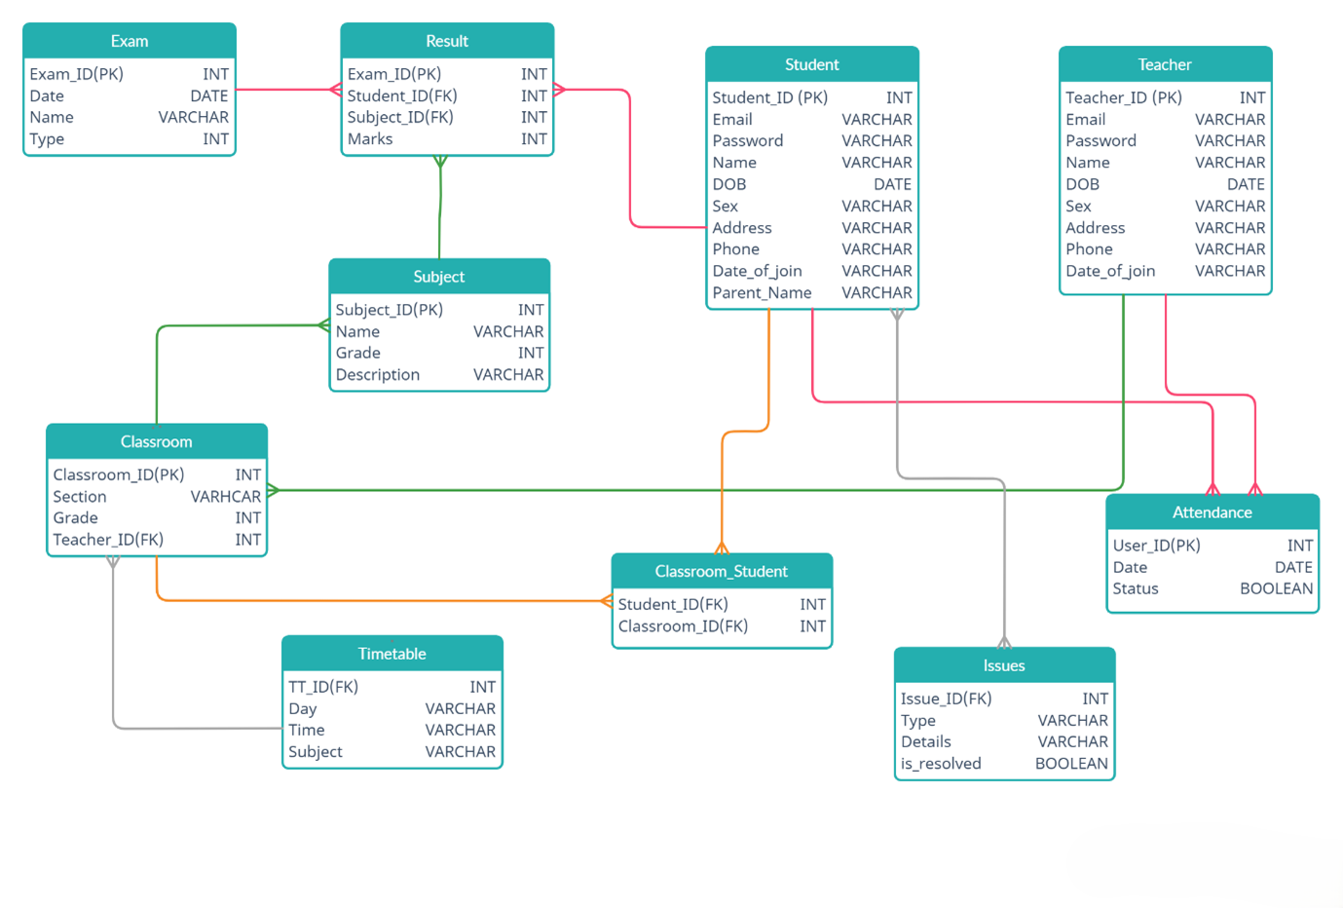

Fig. No :1 **Overview of E-Learning Platforms**

**2.2 Comparison with Existing Solutions**

E-learning platforms have emerged as a dominant force in the education sector, offering a compelling alternative to traditional learning methods. While traditional classrooms provide face-to-face interaction and structured learning environments, they often lack the flexibility and scalability of e-learning platforms. In contrast, e-learning platforms offer a range of features and benefits that address the evolving needs of learners and educators in the digital age.

One key difference between e-learning platforms and traditional classrooms lies in their accessibility. Traditional classrooms are bound by physical location and time constraints, limiting access for students who are geographically dispersed or have scheduling conflicts. E-learning platforms, on the other hand, can be accessed from anywhere with an internet connection, at any time, making education more accessible to a global audience.

Another significant difference is the level of personalization offered by each approach. Traditional classrooms often follow a one-size-fits-all approach, where all students learn the same material at the same pace. E-learning platforms can be tailored to individual learning styles, needs, and preferences. Adaptive learning technologies can adjust the pace, content, and difficulty of instruction based on student performance, providing a more personalized and effective learning experience.

E-learning platforms also offer a wider range of learning resources and multimedia content compared to traditional classrooms. While traditional classrooms may rely primarily on textbooks and lectures, e-learning platforms can incorporate videos, audio recordings, interactive simulations, and other engaging multimedia elements. This can enhance student engagement, improve knowledge retention, and cater to different learning styles.

Assessment methods also differ between the two approaches. Traditional classrooms often rely on standardized tests and exams, which may not accurately measure student learning or provide timely feedback. E-learning platforms can utilize a variety of assessment tools, such as quizzes, online discussions, and peer reviews, to provide more frequent and formative feedback. These tools can also track student progress and identify areas where they may need additional support.

Communication and collaboration are also facilitated differently in e-learning platforms compared to traditional classrooms. While traditional classrooms provide opportunities for face-to-face interaction, e-learning platforms offer a range of communication tools, such as discussion forums, chat rooms, and video conferencing, to support online interaction. These tools can enable students to collaborate on projects, share ideas, and build a sense of community, regardless of their location.

Cost-effectiveness is another important consideration. E-learning platforms can often be more cost-effective than traditional classrooms, especially for large numbers of students. Online courses eliminate the need for physical classrooms, transportation, and other overhead costs. They can also be more scalable, allowing institutions to reach a wider audience without significant additional investment.

However, it is important to note that e-learning platforms also have some limitations compared to traditional classrooms. One potential drawback is the lack of face-to-face interaction, which can be important for building relationships and fostering a sense of community. Some students may also struggle with the self-discipline and motivation required for online learning.

Another challenge is ensuring the quality and credibility of online education. With the proliferation of online courses and programs, it can be difficult to distinguish between reputable institutions and those that offer substandard education. This highlights the importance of accreditation and quality assurance mechanisms for e-learning platforms.

Despite these challenges, e-learning platforms offer numerous advantages over traditional classrooms, and their popularity continues to grow. As technology advances and online learning methodologies improve, e-learning platforms are becoming an increasingly viable and effective alternative to traditional education. They provide greater flexibility, accessibility, personalization, and cost-effectiveness, making education more accessible and equitable for learners around the world.

The integration of new technologies, such as AI, VR, and AR, is further enhancing the capabilities of e-learning platforms. AI-powered tools can provide personalized learning recommendations, automate administrative tasks, and offer intelligent tutoring. VR and AR can create immersive and interactive learning experiences that simulate real-world scenarios. These advancements are making e-learning even more engaging, effective, and transformative.

**2.3 Advantages of Using Django and Python**

Django and Python offer a powerful combination for developing robust, scalable, and maintainable e-learning platforms. Python's simplicity and readability, combined with Django's high-level framework, streamline the development process, allowing developers to focus on building features rather than worrying about low-level details. This results in faster development cycles, cleaner code, and a more efficient workflow.

One of the key advantages of using Python for e-learning development is its extensive library ecosystem. Python boasts a vast collection of libraries and frameworks that can be used to implement various e-learning functionalities, such as content management, user authentication, and multimedia streaming. Libraries like NumPy and Pandas are invaluable for data analysis and progress tracking, while libraries like Django REST Framework simplify the creation of APIs for mobile and front-end integration.

Django, as a web framework, provides a solid foundation for building complex e-learning applications. Its Model-View-Template (MVT) architecture promotes a clean separation of concerns, making it easier to organize and maintain code. Django's built-in security features, such as protection against common web vulnerabilities like SQL injection and cross-site scripting (XSS), ensure the safety of sensitive student data.

Another advantage of Django is its Object-Relational Mapper (ORM), which simplifies database interactions. The ORM allows developers to work with database tables as Python objects, eliminating the need to write raw SQL queries. This not only speeds up development but also makes the code more portable and easier to understand. Django's ORM supports multiple database backends, including PostgreSQL, MySQL, and SQLite, providing flexibility in choosing the right database for the project.

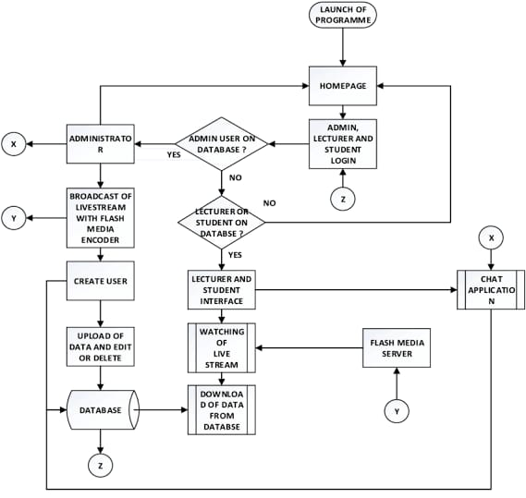

Fig.No:2 **BLOCK DIAGRAM**

A Block diagram for an e learning platform visualizes the core components and their interactions, often using a tiered architecture. The user interface (UI) or presentation layer interfaces with users, while the business Logic Layer Access Processes data and the data acess layer going to handles database interaction .This layer going to help users to access of each page of an website

Python's readability and Django's conventions make it easier for developers to collaborate on e-learning projects. The clear and concise syntax of Python code reduces the learning curve for new developers, while Django's well-defined structure ensures that everyone on the team follows a consistent coding style. This results in fewer errors, improved code maintainability, and increased productivity.

Django's scalability is another crucial advantage for e-learning platforms, which often need to handle a large number of users and courses. Django's architecture is designed to support high traffic loads, and it can be easily scaled horizontally by adding more servers. Python's performance, combined with Django's caching mechanisms, ensures that the platform remains responsive even during peak usage times.

The large and active community surrounding Python and Django is also a significant asset. Developers can find a wealth of online resources, tutorials, and documentation to help them with their projects. The community also contributes to the ongoing development of Python and Django, ensuring that they remain up-to-date with the latest web development trends and best practices.

Python's versatility extends beyond web development, making it a valuable asset for e-learning platforms that may require additional functionality. Python can be used for data analysis, machine learning, and AI, which can be integrated into the platform to provide features such as personalized learning recommendations, automated grading, and intelligent tutoring. This allows for a more holistic and data-driven approach to e-learning.

Django's templating engine provides a flexible and efficient way to generate dynamic HTML pages. Templates can be used to display course content, student progress, and other information in a user-friendly format. Django's template system supports inheritance, allowing developers to create reusable templates and reduce code duplication.

The ease of deployment is another advantage of using Python and Django. Python applications can be deployed on a variety of platforms, including Linux, Windows, and macOS. Django provides tools and documentation to simplify the deployment process, and it can be easily integrated with web servers like Apache and Nginx.

In conclusion, the combination of Python and Django offers numerous advantages for developing e-learning platforms. Their simplicity, readability, extensive libraries, robust framework, scalability, and active community make them an ideal choice for building powerful, efficient, and user-friendly online learning environments.

**3. System Analysis and Design**

**3.1 Requirements Gathering**

The initial phase of system analysis and design involves a crucial process known as requirements gathering. This stage lays the foundation for the entire project by identifying and documenting the specific needs and expectations of the stakeholders, including educators, students, and administrators. Effective requirements gathering ensures that the final e-learning platform aligns with its intended purpose and meets the diverse needs of its users.

The process typically begins with stakeholder consultations, where analysts conduct interviews, surveys, and focus groups to gather insights into their needs and pain points. Educators, for example, may express the need for tools to create and manage course content, deliver lectures, assess student performance, and facilitate online discussions. Students, on the other hand, might emphasize the importance of user-friendly interfaces, accessible learning materials, interactive features, and personalized learning experiences.

In addition to stakeholder consultations, analysts also review existing systems, documentation, and best practices to identify relevant requirements. This may involve examining other e-learning platforms, educational standards, and technological advancements to ensure that the proposed system incorporates the latest features and functionalities. The goal is to gather a comprehensive set of requirements that covers all aspects of the e-learning platform.

The requirements gathering process also involves prioritizing and validating the collected requirements. Analysts work with stakeholders to determine the relative importance of each requirement and to ensure that they are feasible, measurable, and achievable within the project's constraints. This step helps to avoid scope creep and ensures that the development team focuses on the most critical features.

Documentation is a key aspect of requirements gathering. All gathered requirements are carefully documented in a requirements specification document, which serves as a blueprint for the development team. This document includes detailed descriptions of each requirement, including its purpose, functionality, and any constraints or dependencies. It also includes diagrams, use cases, and other visual aids to help stakeholders and developers understand the requirements.

The requirements gathering process is iterative and may involve several rounds of feedback and refinement. As the development team begins to design and implement the system, they may uncover new requirements or need to clarify existing ones. Analysts work closely with the development team to ensure that the requirements remain aligned with the stakeholders' needs and that any changes are properly documented and approved.

Effective communication and collaboration between analysts, stakeholders, and developers are essential for successful requirements gathering. Analysts act as a bridge between these groups, ensuring that everyone is on the same page and that the final system meets the needs of all users. This involves active listening, clear communication, and a willingness to compromise.

The outcome of the requirements gathering process is a well-defined set of requirements that provides a solid foundation for the design and development of the e-learning platform. These requirements serve as a guide for the development team, ensuring that the final product meets the needs of its users and achieves its intended purpose. They also provide a basis for testing and validation, ensuring that the system functions as expected and delivers the desired outcomes.

A crucial aspect of requirements gathering is anticipating future needs and scalability. The e-learning platform should be designed to accommodate growth in the number of users, courses, and features. This requires careful consideration of potential changes in technology, pedagogy, and user expectations.

By following a thorough and well-structured requirement gathering process, the development team can ensure that the e-learning platform is built on a solid foundation, meets the needs of its users, and is capable of evolving over time. This investment in the initial stages of the project pays off in the long run by reducing the risk of costly rework and ensuring user satisfaction.

**3.2 Functional and Non-Functional Requirements**

The development of a successful e-learning platform hinges on a clear understanding and articulation of both functional and non-functional requirements. Functional requirements define the specific actions and processes that the system must perform, while non-functional requirements outline the qualities and constraints that the system must adhere to. Both types of requirements are essential for ensuring that the platform meets the needs of its users and operates effectively.

Functional requirements for an e-learning platform typically include features such as user registration and authentication, course creation and management, content delivery, assessment tools, communication channels, and progress tracking. For example, educators should be able to create and manage courses, upload learning materials, design quizzes and assignments, and track student performance. Students, on the other hand, should be able to enroll in courses, access course content, participate in discussions, submit assignments, and view their grades.

In addition to these core functionalities, functional requirements may also include features such as personalized learning paths, adaptive testing, gamification, and multimedia support. These features can enhance the learning experience, increase student engagement, and provide a more effective and enjoyable way to acquire knowledge and skills. The specific functional requirements will vary depending on the target audience, the scope of the platform, and the pedagogical goals.

Non-functional requirements, on the other hand, define the qualities that the system must possess, such as usability, reliability, performance, security, and scalability. For example, the e-learning platform should be user-friendly, with an intuitive interface that is easy to navigate and use. It should also be reliable, with minimal downtime and data loss, ensuring that users can access the platform and its resources whenever they need them.

Performance is another critical non-functional requirement. The platform should be responsive and efficient, with fast loading times and minimal delays. It should also be able to handle a large number of concurrent users without experiencing performance degradation. Security is paramount, as the platform will store sensitive student data, such as personal information and grades. Robust security measures, including encryption, access controls, and regular security audits, are essential to protect this data from unauthorized access.

Scalability is also a key consideration, as the e-learning platform should be able to accommodate future growth in the number of users, courses, and features. The system architecture and database design should be flexible and scalable, allowing the platform to expand without requiring major modifications. Usability is crucial for ensuring that both educators and students can use the platform effectively and efficiently.

Other non-functional requirements may include maintainability, portability, and interoperability. Maintainability refers to the ease with which the system can be modified or updated, while portability refers to its ability to run on different platforms or environments. Interoperability refers to the platform's ability to integrate with other systems, such as student information systems or learning management systems.

The process of defining functional and non-functional requirements is iterative and involves close collaboration between stakeholders, analysts, and developers. Stakeholders provide input on their needs and expectations, while analysts translate these into specific requirements. Developers provide feedback on the feasibility and technical implications of the requirements.

Documenting functional and non-functional requirements is essential for ensuring that everyone involved in the project has a clear understanding of what needs to be built. The requirements specification document serves as a contract between the stakeholders and the development team, outlining the agreed-upon features and qualities of the system. This document is used throughout the development process to guide design, implementation, testing, and validation.

By carefully defining and documenting both functional and non-functional requirements, the development team can ensure that the e-learning platform meets the needs of its users, operates effectively, and provides a high-quality learning experience. This investment in the early stages of the project pays off in the long run by reducing the risk of costly rework and ensuring user satisfaction.

**3.3 System Architecture**

The system architecture of an e-learning platform provides a blueprint for its design, development, and deployment. It defines the components of the system, their relationships, and the principles and guidelines governing their interaction. A well-designed system architecture is crucial for ensuring that the platform is scalable, maintainable, reliable, and secure.

A typical e-learning platform architecture consists of several key components, including a presentation layer, an application layer, and a data layer. The presentation layer is responsible for the user interface and user experience, providing the means for users to interact with the system. This layer may include web pages, mobile apps, and other interfaces that allow students and educators to access course materials, participate in discussions, and manage their learning activities.

The application layer contains the business logic of the e-learning platform, handling the processing of user requests, the enforcement of business rules, and the coordination of data access. This layer includes components such as user authentication and authorization, course management, content delivery, assessment management, and communication services. It is responsible for ensuring that the platform functions correctly and efficiently.

The data layer is responsible for storing and managing the data used by the e-learning platform. This includes user information, course content, student records, grades, and other data related to the learning process. The data layer typically consists of a database management system (DBMS), which provides mechanisms for storing, retrieving, and manipulating data. The choice of DBMS depends on factors such as the size and complexity of the data, the performance requirements of the platform, and the scalability needs.

In addition to these core layers, an e-learning platform architecture may also include other components, such as a search engine, a content management system (CMS), a learning management system (LMS), and an analytics engine. A search engine allows users to quickly find relevant course materials and information, while a CMS provides tools for creating, managing, and publishing course content. An LMS provides a framework for organizing and delivering online courses, tracking student progress, and managing grades. An analytics engine collects and analyzes data on student activity, performance, and engagement, providing insights for improving the learning experience.

The choice of technology for each layer of the system architecture is crucial. For the presentation layer, technologies such as HTML, CSS, JavaScript, and various front-end frameworks may be used. For the application layer, programming languages such as Python, Java, or PHP, and web frameworks such as Django, Spring, or Laravel may be employed. For the data layer, database management systems such as PostgreSQL, MySQL, or Oracle may be selected.

The system architecture should also address non-functional requirements, such as scalability, maintainability, reliability, and security. Scalability can be achieved through techniques such as load balancing, caching, and database sharding. Maintainability can be enhanced through modular design, clear coding standards, and comprehensive documentation. Reliability can be ensured through redundancy, fault tolerance, and regular backups. Security can be addressed through measures such as encryption, access controls, and security audits.

The design of the system architecture is an iterative process that involves trade-offs and compromises. The development team must consider factors such as cost, performance, scalability, and maintainability when making architectural decisions. They must also ensure that the architecture aligns with the functional and non-functional requirements of the e-learning platform.

Documentation is a critical aspect of system architecture design. The architecture should be documented in a clear and concise manner, using diagrams, models, and textual descriptions. This documentation serves as a guide for the development team, ensuring that everyone understands the structure and behavior of the system. It also facilitates communication with stakeholders and provides a basis for future maintenance and evolution of the platform.

A well-designed system architecture provides a solid foundation for the development of a successful e-learning platform. It ensures that the platform is scalable, maintainable, reliable, and secure, and that it meets the needs of its users. By carefully considering the various components of the system and their interactions, the development team can create a platform that provides a high-quality learning experience and supports the goals of online education.

As technology evolves, the system architecture of e-learning platforms will continue to adapt. Emerging technologies such as cloud computing, microservices, and serverless computing are influencing the way these platforms are designed and deployed. These technologies offer greater scalability, flexibility, and cost-effectiveness, enabling e-learning platforms to reach a wider audience and provide more personalized and engaging learning experiences.

**3.4 Database Design**

Database design is a critical aspect of developing an e-learning platform, as it involves organizing and structuring the data that the platform will use. A well-designed database ensures that data is stored efficiently, can be accessed quickly, and remains consistent and accurate. It also supports the scalability and maintainability of the platform, allowing it to grow and evolve over time.

The database for an e-learning platform typically consists of several interconnected tables that store information about users, courses, content, assessments, and other aspects of the learning process. User tables store data such as usernames, passwords, and roles (e.g., student, educator, administrator). Course tables store information about course titles, descriptions, schedules, and instructors. Content tables store the actual learning materials, such as text, videos, and presentations. Assessment tables store data about quizzes, assignments, and grades.

In addition to these core tables, the database may also include tables for managing discussions, tracking student progress, storing user preferences, and logging system activity. The specific tables and their attributes will depend on the functional requirements of the e-learning platform and the types of data that need to be stored. The goal is to create a database schema that is both comprehensive and efficient.

Normalization is a key principle in database design. It involves organizing data in a way that minimizes redundancy and improves data integrity. Normalization reduces the amount of storage space required, simplifies data updates, and prevents inconsistencies. It also makes the database more flexible and adaptable to changes in the platform's requirements.

Relationships between tables are established using primary keys and foreign keys. A primary key is a unique identifier for a row in a table, while a foreign key is a field in one table that refers to the primary key in another table. These relationships allow the database to store related data in separate tables and to retrieve it efficiently using joins. For example, a student table may have a foreign key that references the primary key in a course table, allowing the system to determine which courses a student is enrolled in.

Indexing is another important technique for improving database performance. An index is a data structure that allows the database to quickly locate specific rows in a table. By creating indexes on frequently accessed columns, such as student ID or course ID, the database can retrieve data much faster than by scanning the entire table. However, indexes also consume storage space and can slow down data updates, so they should be used judiciously.

The choice of database management system (DBMS) is also a critical decision. Popular DBMS options for e-learning platforms include PostgreSQL, MySQL, and Oracle. PostgreSQL is a powerful open-source DBMS that offers excellent performance, reliability, and scalability. MySQL is another popular open-source DBMS that is widely used for web applications. Oracle is a commercial DBMS that is known for its robustness and advanced features. The choice of DBMS depends on factors such as the size and complexity of the data, the performance requirements of the platform, and the budget.

Database security is paramount, as the e-learning platform will store sensitive student data, such as personal information and grades. The database should be protected from unauthorized access through measures such as strong passwords, access controls, and encryption. Regular backups should also be performed to ensure that data can be recovered in case of a system failure or data loss.

As the e-learning platform evolves, the database design may need to be modified to accommodate new features or changes in the data requirements. Database migrations provide a mechanism for making these changes in a controlled and automated manner. Migrations allow developers to modify the database schema, add or remove tables, and alter table structures without losing existing data.

Documentation is a critical aspect of database design. The database schema, including tables, columns, relationships, and constraints, should be documented in a clear and concise manner. This documentation serves as a guide for developers and database administrators, ensuring that everyone understands the structure and organization of the data. It also facilitates database maintenance, troubleshooting, and future modifications.

A well-designed database is essential for the successful operation of an e-learning platform. It ensures that data is stored efficiently, accessed quickly, and remains consistent and accurate. By following sound database design principles and best practices, the development team can create a database that supports the scalability, maintainability, and security of the platform, and that provides a solid foundation for delivering a high-quality learning experience.

**3.5 User Interface Design**

User interface (UI) design is a critical aspect of developing an e-learning platform, as it directly impacts the user experience and the effectiveness of the learning process. A well-designed UI should be intuitive, user-friendly, and visually appealing, making it easy for both educators and students to navigate the platform and access its features. It should also be accessible to users with disabilities and adaptable to different devices and screen sizes.

The UI design process typically begins with user research, which involves gathering information about the target audience, their needs, and their preferences. This research may include surveys, interviews, and usability testing. The goal is to understand how users will interact with the platform and what features and functionalities are most important to them.

Based on the user research, designers create wireframes, which are low-fidelity prototypes that outline the basic structure and layout of the UI. Wireframes show the placement of elements such as navigation menus, content areas, and buttons, without focusing on the visual details. This allows designers to quickly iterate on the design and get feedback from stakeholders before investing time in more detailed mockups.

Once the wireframes are approved, designers create mockups, which are high-fidelity prototypes that show the visual design of the UI. Mockups include details such as colors, fonts, images, and other visual elements. They provide a realistic representation of how the final UI will look and feel. Designers may use design tools such as Sketch, Figma, or Adobe XD to create mockups.

The UI design should adhere to usability principles, such as consistency, clarity, and simplicity. Consistency means that the UI elements and navigation patterns should be consistent throughout the platform, making it easier for users to learn and use the system. Clarity means that the information on the UI should be easy to understand and free of jargon or technical terms. Simplicity means that the UI should be clean and uncluttered, with only the essential elements present.

Accessibility is another important consideration in UI design. The UI should be designed to be accessible to users with disabilities, such as visual impairments, hearing impairments, or motor impairments. This may involve providing alternative text for images, using sufficient color contrast, and ensuring that the UI can be navigated using a keyboard or screen reader.

Responsive design is also crucial, as users may access the e-learning platform on a variety of devices, such as desktops, laptops, tablets, and smartphones. The UI should be designed to adapt to different screen sizes and orientations, providing a consistent and optimal experience on all devices. This may involve using flexible layouts, scalable images, and media queries.

Navigation is a key aspect of UI design. The navigation should be clear, intuitive, and easy to use, allowing users to quickly find the information or functionality they need. This may involve using a hierarchical menu structure, breadcrumbs, and search functionality. The navigation should also be consistent across different pages and sections of the platform.

Feedback is an important element of UI design. The UI should provide clear and timely feedback to users, letting them know the results of their actions. This may involve displaying confirmation messages, error messages, or progress indicators. Feedback helps users understand what is happening and how to proceed.

**4. Implementation**

The implementation phase is where the design of the e-learning platform is brought to life through the development of software code and the configuration of hardware and systems. This stage involves translating the system design specifications into a functional platform that meets the requirements gathered in the earlier phases. Effective implementation requires a well-defined process, a skilled development team, and the use of appropriate technologies and tools.

**4.1 Technology Stack**

The technology stack for an e-learning platform comprises the set of technologies used to build, deploy, and run the application. A well-chosen technology stack can significantly impact the platform's performance, scalability, maintainability, and security. The stack typically includes programming languages, frameworks, databases, web servers, and other tools.

For the e-learning platform, a combination of Python and Django is a popular choice for the backend development. Python is a versatile and readable programming language with a large ecosystem of libraries and frameworks. Django is a high-level Python web framework that simplifies the development of complex web applications. It provides features such as an ORM (Object-Relational Mapper), a templating engine, and built-in security, which can accelerate the development process and improve the quality of the code.

On the frontend, technologies such as HTML, CSS, and JavaScript are used to create the user interface. HTML provides the structure of the web pages, CSS provides the styling, and JavaScript provides the interactivity. Frontend frameworks such as React, Angular, or Vue.js can be used to build complex and dynamic user interfaces. These frameworks offer features such as component-based architecture, state management, and routing, which can simplify frontend development and improve performance.

A database management system (DBMS) is required to store and manage the data for the e-learning platform. Popular choices include PostgreSQL, MySQL, and cloud-based solutions like AWS RDS or Google Cloud SQL. PostgreSQL is a powerful and reliable open-source DBMS that is well-suited for complex applications. MySQL is another popular open-source DBMS that is widely used for web development. Cloud-based solutions offer scalability, availability, and ease of management.

A web server is needed to handle HTTP requests and serve the web pages and other assets of the e-learning platform. Popular choices include Apache, Nginx, and cloud-based solutions like AWS Elastic Beanstalk or Google App Engine. Nginx is a high-performance web server that is known for its speed and efficiency. Apache is a widely used web server that offers a wide range of features and modules. Cloud-based solutions provide scalability, load balancing, and automated deployment.

Other technologies that may be included in the stack are caching systems like Redis or Memcached, message queues like RabbitMQ or Kafka, and search engines like Elasticsearch. Caching systems can improve performance by storing frequently accessed data in memory. Message queues can enable asynchronous processing of tasks, such as sending email notifications or processing large amounts of data. Search engines can provide fast and efficient search functionality.

The choice of technology stack depends on various factors, such as the project requirements, the size and complexity of the platform, the development team's expertise, and the budget. It is important to select technologies that are well-suited for the specific needs of the e-learning platform and that can provide the desired level of performance, scalability, maintainability, and security.

The technology stack should also be flexible and adaptable to future changes. As the e-learning platform evolves, new features may need to be added, and the underlying technologies may need to be updated. A modular and well-architected technology stack can make it easier to incorporate these changes without disrupting the existing functionality.

Documentation is crucial for the technology stack. The technologies used, their versions, and their configuration should be documented in a clear and concise manner. This documentation serves as a guide for the development team, the system administrators, and anyone else who needs to understand or work with the platform. It also facilitates troubleshooting, maintenance, and future upgrades.

By carefully selecting and documenting the technology stack, the development team can ensure that the e-learning platform is built on a solid foundation, meets the needs of its users, and can be maintained and evolved over time. A well-chosen technology stack can also improve the development process, increase productivity, and reduce the overall cost of the project.

**4.2 Backend Development (Django)**

Backend development is the process of building the server-side logic of the e-learning platform. This involves creating the components that handle user requests, process data, interact with the database, and enforce business rules. A robust and well-designed backend is essential for ensuring that the platform is reliable, secure, and scalable.

Django is a popular Python web framework that is well-suited for backend development. It provides a high-level abstraction over the underlying web technologies, allowing developers to focus on building the core features of the e-learning platform. Django follows the Model-View-Template (MVT) architecture, which promotes a clean separation of concerns and makes the code more organized and maintainable.

The Model layer in Django is responsible for defining the data structure of the e-learning platform. Django's ORM (Object-Relational Mapper) allows developers to interact with the database using Python code, rather than writing raw SQL queries. This simplifies database operations and makes the code more portable across different database systems. Models define the tables in the database and the relationships between them.

The View layer in Django contains the business logic of the e-learning platform. Views are Python functions or classes that handle HTTP requests and return responses. They process data from the Model layer, render templates, and generate the HTML that is sent to the user's browser. Django provides various tools and helpers for handling forms, validating data, and implementing authentication and authorization.

The Template layer in Django is responsible for generating the HTML that is displayed to the user. Django's templating engine allows developers to create dynamic web pages that can display data from the Model layer. Templates can also include control structures, such as loops and conditional statements, to generate HTML dynamically. Django's templating system is extensible and allows developers to create custom tags and filters.

Django provides a built-in admin interface that can be used to manage the data in the e-learning platform. The admin interface is automatically generated based on the models defined in the application. It provides a user-friendly way to create, read, update, and delete data, making it easy for administrators to manage the platform's content and users.

Security is a crucial consideration in backend development. Django provides several built-in security features, such as protection against common web vulnerabilities like SQL injection, cross-site scripting (XSS), and cross-site request forgery (CSRF). Django also provides tools for handling user authentication and authorization, ensuring that only authorized users can access certain parts of the platform.

Scalability is another important factor in backend development. The e-learning platform should be able to handle a large number of concurrent users and requests. Django can be scaled horizontally by adding more servers and using load balancing. Django also supports caching, which can improve performance by storing frequently accessed data in memory.

Testing is essential for ensuring the quality of the backend code. Django provides a testing framework that allows developers to write unit tests, integration tests, and functional tests. These tests can be run automatically to verify that the code is working correctly and that new changes do not break existing functionality.

Documentation is crucial for the backend development process. The code should be well-documented, with clear and concise comments that explain the purpose and functionality of each module, class, and function. Django also provides extensive documentation, which can help developers learn the framework and use it effectively.

By using Django for backend development, the development team can create a robust, secure, and scalable e-learning platform. Django's high-level features, built-in security, and large community make it an excellent choice for building complex web applications. Django also promotes good coding practices and makes it easier to maintain and extend the platform over time.

**4.3 Frontend Development**

Frontend development is the process of building the user interface (UI) of the e-learning platform. This involves creating the web pages and other interactive elements that users see and interact with in their browsers. A well-designed frontend is crucial for providing a positive user experience and making the platform easy to use and navigate.

HTML, CSS, and JavaScript are the core technologies of frontend development. HTML provides the structure of the web pages, defining the elements such as headings, paragraphs, and images. CSS provides the styling, controlling the appearance of the pages, such as colors, fonts, and layout. JavaScript provides the interactivity, allowing the pages to respond to user actions, such as clicks and form submissions.

For complex e-learning platforms, frontend frameworks such as React, Angular, or Vue.js are often used. These frameworks provide a component-based architecture, which makes it easier to build and maintain large and complex UIs. They also offer features such as state management, routing, and a rich ecosystem of libraries and tools.

React is a popular JavaScript library for building user interfaces. It allows developers to create reusable UI components that can be combined to build complex UIs. React uses a virtual DOM (Document Object Model) to optimize performance and update the UI efficiently. It also has a large and active community, which provides a wealth of resources and support.

Angular is a powerful JavaScript framework for building web applications. It provides a comprehensive set of features, including a component-based architecture, a powerful templating engine, and a robust routing system. Angular also has a strong emphasis on TypeScript, which adds type checking and improves code quality.

Vue.js is a progressive JavaScript framework that is known for its simplicity and ease of use. It allows developers to create interactive UIs with a minimal amount of code. Vue.js is also highly flexible and can be easily integrated into existing projects. It has a growing community and a good selection of libraries and tools.

Responsive design is a crucial aspect of frontend development for e-learning platforms. The UI should be designed to adapt to different screen sizes and devices, such as desktops, laptops, tablets, and smartphones. This ensures that users can access the platform and its content on any device, without sacrificing usability or functionality.

Accessibility is another important consideration. The UI should be designed to be accessible to users with disabilities, such as visual impairments, hearing impairments, or motor impairments. This involves following accessibility guidelines, such as providing alternative text for images, using sufficient color contrast, and ensuring that the UI can be navigated using a keyboard or screen reader.

Performance is also a key factor in frontend development. The UI should be fast and responsive, loading quickly and providing a smooth and seamless user experience. This requires optimizing the code, minimizing the number of HTTP requests, and using techniques such as caching and lazy loading.

Testing is essential for ensuring the quality of the frontend code. Frontend developers should write unit tests, integration tests, and end-to-end tests to verify that the UI is working correctly and that it meets the requirements. Testing frameworks such as Jest, Mocha, and Cypress can be used to automate the testing process.

Documentation is crucial for frontend development. The code should be well-documented, with clear and concise comments that explain the purpose and functionality of each component, module, and function. Frontend frameworks also provide extensive documentation, which can help developers learn the framework and use it effectively.

By using modern frontend technologies and following best practices, frontend developers can create a user-friendly, accessible, and performant UI for the e-learning platform.

**4.4 User Authentication and Authorization**

User authentication and authorization are critical aspects of e-learning platform implementation. They ensure that only authorized users can access the platform and its resources, and that each user can only access the features and data that they are allowed to. Proper authentication and authorization are essential for protecting sensitive student data, preventing unauthorized access, and maintaining the integrity of the platform.

Authentication is the process of verifying the identity of a user. This typically involves asking the user to provide credentials, such as a username and password, and then checking those credentials against a database of registered users. If the credentials match, the user is authenticated and allowed to access the platform.

Authorization is the process of determining what actions an authenticated user is allowed to perform. This involves assigning roles or permissions to users, and then checking those roles or permissions before allowing the user to access a particular resource or perform a particular action. For example, an administrator may be allowed to create and manage courses, while a student may only be allowed to view courses and submit assignments.

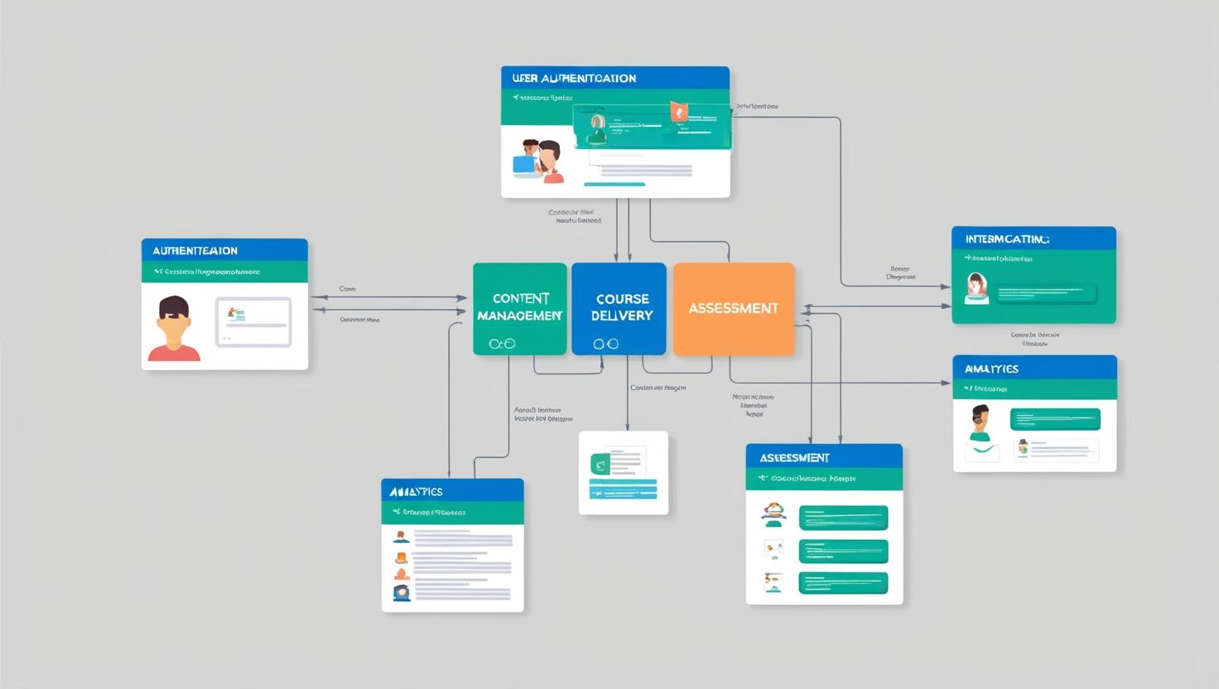

Fig.No :3 **User Authentication and Authorization**

Django provides built-in support for user authentication and authorization. The django.contrib.auth module handles user authentication, providing features such as user registration, login, logout, and password management. It also provides a user model that can be extended to store additional user information.

Django's authentication system uses a pluggable authentication backend, which allows developers to use different authentication methods, such as username/password, email/password, or social login. Django also provides middleware that can be used to protect views and restrict access to authenticated users.

Authorization in Django is typically handled using permissions and roles. Permissions are fine-grained controls that specify what actions a user is allowed to perform. Roles are collections of permissions that can be assigned to users. Django provides a flexible and extensible permission system that can be customized to meet the specific needs of the e-learning platform.

For example, you can define permissions for creating courses, editing courses, deleting courses, submitting assignments, grading assignments, and so on. You can then create roles such as "administrator," "instructor," and "student," and assign the appropriate permissions to each role. When a user logs in, their roles and permissions are checked to determine what they are allowed to do.

In addition to Django's built-in authentication and authorization features, there are also third-party libraries and packages that can be used to enhance the security of the e-learning platform. For example, libraries like Django Guardian provide more fine-grained control over object-level permissions, allowing you to specify which users are allowed to access specific instances of a model.

Security best practices should be followed when implementing authentication and authorization. This includes using strong passwords, salting and hashing passwords, protecting against common attacks such as brute-force attacks and session hijacking, and regularly updating the system to patch security vulnerabilities.

User experience is also an important consideration in authentication and authorization. The login and registration process should be user-friendly and intuitive. Users should be able to easily reset their passwords if they forget them. The system should also provide clear and helpful error messages when users enter incorrect credentials or try to access resources that they are not authorized to access.

Testing is essential for ensuring that the authentication and authorization system is working correctly. Developers should write unit tests and integration tests to verify that users can log in and log out, that roles and permissions are being correctly assigned and checked, and that unauthorized access is being properly prevented.

Documentation is crucial for the authentication and authorization system. The implementation details, including the authentication methods used, the permission structure, and any customizations, should be documented in a clear and concise manner. This documentation serves as a guide for developers, system administrators, and anyone else who needs to understand or work with the system.

**4.5 Course and Content Management**

Course and content management is a core aspect of e-learning platform implementation. It involves providing the tools and functionalities for educators to create, organize, and deliver course materials, and for students to access and interact with that content. An effective course and content management system is essential for facilitating the learning process and ensuring that the platform provides a valuable educational experience.

Django provides a solid foundation for building a course and content management system. Its ORM (Object-Relational Mapper) allows developers to define the data models for courses, lessons, modules, and other content types. Its templating engine provides a flexible way to display course materials to students. And its built-in admin interface provides a user-friendly way for educators to manage their courses and content.

Educators should be able to create courses, define their structure, and add content to them. This may involve creating modules, lessons, quizzes, assignments, and other learning activities. The system should support a variety of content types, such as text, images, videos, audio files, and interactive simulations. It should also provide tools for formatting and organizing content, such as a WYSIWYG (What You See Is What You Get) editor.

The system should also allow educators to manage course enrollment, set prerequisites, and track student progress. It may provide features for creating learning paths, which guide students through the course materials in a structured way. It may also provide tools for communication, such as discussion forums, chat rooms, and messaging systems, which enable educators and students to interact with each other.

Students should be able to easily access course materials, navigate through the course structure, and participate in learning activities. The system should provide a clear and intuitive interface that allows students to find the content they need and to track their own progress. It may also provide features for collaboration, such as group projects and peer review, which enable students to learn from each other.

Version control is an important aspect of content management. The system should allow educators to update course materials and track changes over time. It may provide features for creating drafts, reviewing changes, and publishing new versions of content. This ensures that students always have access to the latest and most accurate information.

Search functionality is essential for large e-learning platforms with a lot of content. The system should allow students and educators to quickly find the courses and materials they need. This may involve implementing a full-text search engine, such as Elasticsearch, which can index the content and provide fast and accurate search results.

Accessibility is a crucial consideration in course and content management. The content should be designed to be accessible to students with disabilities, such as visual impairments, hearing impairments, or motor impairments. This involves following accessibility guidelines, such as providing alternative text for images, using sufficient color contrast, and ensuring that the content can be accessed using assistive technologies.

Scalability is also an important factor. The course and content management system should be able to handle a large number of courses, students, and content items. This may require using techniques such as caching, content delivery networks (CDNs), and database optimization.

Testing is essential for ensuring that the course and content management system is working correctly. Developers should write unit tests and integration tests to verify that educators can create and manage courses, that students can access and interact with the content, and that all the features are working as expected.

Documentation is crucial for the course and content management system. The system should be well-documented, with clear and concise instructions on how to create, manage, and access courses and content. This documentation serves as a guide for educators, students, and system administrators, and helps to ensure that the platform is used effectively.

By implementing a comprehensive and user-friendly course and content management system, the e-learning platform can provide a valuable educational experience for both educators and students. Django's flexibility and extensibility make it a powerful tool for building such a system.

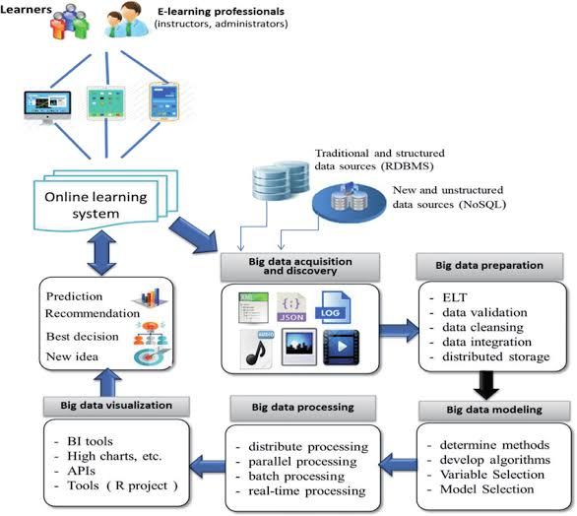

Fig.No:4 **Course and Content Management**

**5. Features and Functionalities**

An e-learning platform is equipped with a range of features and functionalities designed to facilitate online learning and provide a robust educational experience. These features cater to the needs of both educators and students, supporting various aspects of the learning process, from course creation and delivery to student engagement and assessment.

**5.1 Course Management**

Course management is a fundamental aspect of an e-learning platform, providing educators with the tools to create, organize, and deliver online courses effectively. This feature enables educators to structure their courses, upload learning materials, and manage student enrollment, among other tasks. A well-designed course management system simplifies the process of online teaching and ensures a seamless learning experience for students.

Educators can create courses with detailed descriptions, learning objectives, and schedules. They can organize course content into modules, lessons, or topics, providing a clear and structured learning path for students. The system supports various types of learning materials, including text documents, presentations, videos, and interactive simulations.

The course management feature also allows educators to manage student enrollment, set course prerequisites, and control access to course materials. They can track student progress, monitor their activity, and communicate with them through announcements, emails, or discussion forums. The system may also provide tools for grading assignments, providing feedback, and generating reports on student performance.

For students, the course management feature provides a user-friendly interface to access course materials, view their grades, and track their progress. They can easily navigate through the course structure, access different types of content, and submit assignments online. The system may also provide tools for collaboration, such as group projects or peer reviews, which enhance the learning experience.

Effective course management also includes the ability to manage course versions, update content, and archive old courses. This ensures that the platform remains up-to-date and that students always have access to the latest version of the course materials. The system may also provide tools for course evaluation, allowing educators to gather feedback from students and improve their courses over time.

A robust course management system also supports the integration of external tools and resources, such as video conferencing software, plagiarism detection tools, and learning analytics platforms. This enhances the functionality of the platform and provides educators with a wider range of tools to support their teaching.

The design of the course management system should be flexible and customizable, allowing educators to adapt it to their specific needs and teaching styles. It should also be scalable, capable of handling a large number of courses and students without compromising performance.

Documentation is essential for the course management feature. The system should provide clear and concise instructions on how to create, manage, and access courses. This documentation serves as a guide for educators and students, ensuring that they can use the system effectively.

By providing a comprehensive set of course management tools, an e-learning platform can empower educators to deliver high-quality online education and create engaging learning experiences for students. A well-designed course management system is a key component of a successful e-learning platform.

**5.2 User Management (Students & Educators)**

User management is a critical aspect of an e-learning platform, encompassing the processes of registering, authenticating, and managing user accounts. This feature ensures that both students and educators can access the platform securely and efficiently, with appropriate roles and permissions. A well-designed user management system is essential for maintaining the integrity of the platform and providing a personalized learning experience.

The user management system typically includes functionalities for user registration, where new users can create accounts by providing their personal information. This process may involve verifying email addresses or using other authentication methods to ensure the validity of the accounts. Once registered, users can log in to the platform using their credentials, such as username and password.

The system also manages user roles, which define the level of access and the permissions that each user has within the platform. In an e-learning platform, there are typically two primary roles: student and educator. Educators have the ability to create and manage courses, upload learning materials, and assess student performance. Students can enroll in courses, access course content, and participate in online activities.

In addition to these primary roles, the system may also include other roles, such as administrator, teaching assistant, or guest. Administrators have the highest level of access and are responsible for managing the platform, including user accounts, system settings, and security. Teaching assistants may assist educators in managing courses and grading assignments. Guests may have limited access to the platform, such as viewing course catalogs or attending specific lectures.

The user management system also handles user profiles, allowing users to update their personal information, such as their name, email address, and profile picture. It may also allow users to set their preferences, such as language, time zone, and notification settings. This ensures that the platform can provide a personalized experience for each user.

Security is a paramount concern in user management. The system should employ robust security measures to protect user accounts and sensitive information, such as passwords. This may include using encryption, salting and hashing passwords, and implementing access controls. The system should also provide tools for password recovery and account recovery in case users forget their credentials or lose access to their accounts.

The user management system should also support user authentication, which is the process of verifying the identity of a user when they try to log in to the platform. This may involve using traditional username and password authentication, or more advanced methods, such as two-factor authentication or single sign-on (SSO). Two-factor authentication adds an extra layer of security by requiring users to provide a second form of identification, such as a code sent to their mobile device. SSO allows users to log in to the platform using their credentials from another system, such as a social media account or a university account.

The system should also provide tools for managing user sessions, which are the periods of time that a user is logged in to the platform. This may include setting session timeouts, which automatically log users out after a certain period of inactivity, and providing users with the ability to log out manually.

Scalability is an important consideration in user management. The system should be able to handle a large number of user accounts without compromising performance. This may require using techniques such as database optimization, caching, and load balancing.

Documentation is essential for the user management feature. The system should provide clear and concise instructions on how to register, log in, and manage user accounts. This documentation serves as a guide for users and administrators, ensuring that they can use the system effectively.

By providing a comprehensive and secure user management system, an e-learning platform can ensure that both students and educators can access the platform easily and safely. A well-designed user management system is a key component of a successful e-learning platform

**5.3 Assignment and Quiz Creation**

Assignment and quiz creation is a crucial feature of an e-learning platform, enabling educators to assess student learning and provide feedback on their progress. This feature allows educators to design various types of assessments, from simple quizzes to complex assignments, and to deliver them online. A robust assignment and quiz creation system is essential for measuring student understanding and promoting effective learning.

The assignment and quiz creation system typically provides a range of question types, such as multiple-choice, true/false, short answer, essay, and file upload. Educators can create quizzes with automated grading for objective question types, such as multiple-choice and true/false, and manual grading for subjective question types, such as essay and short answer. The system may also support question banks, which allow educators to create a repository of questions that can be reused in multiple assessments.

For assignments, educators can provide detailed instructions, set deadlines, and specify submission requirements. Students can submit their assignments online, and educators can grade them, provide feedback, and track student performance. The system may also support different grading methods, such as rubric-based grading or peer review.

The system may also include features for creating different types of quizzes and assignments, such as timed quizzes, group assignments, or individual projects. Timed quizzes allow educators to set a time limit for students to complete the assessment, while group assignments encourage collaboration and teamwork. Individual projects allow students to demonstrate their understanding of the course material through a more comprehensive task.

The assignment and quiz creation system may also support the integration of multimedia elements, such as images, videos, or audio files, into the assessment questions. This can make the assessments more engaging and provide a more authentic assessment experience.

The system may also include features for randomizing questions, shuffling answer options, and providing feedback to students. Randomizing questions and shuffling answer options can help to prevent cheating, while providing feedback can help students to understand their mistakes and improve their learning.

The system should also provide tools for managing grades, calculating final scores, and generating reports on student performance. Educators should be able to easily view student grades, track their progress, and identify areas where they may need additional support. The system may also provide tools for exporting grades to other systems, such as student information systems.

Accessibility is an important consideration in assignment and quiz creation. The system should allow educators to create assessments that are accessible to students with disabilities, such as visual impairments or hearing impairments. This may involve providing alternative text for images, using sufficient color contrast, and ensuring that the assessments can be completed using assistive technologies.

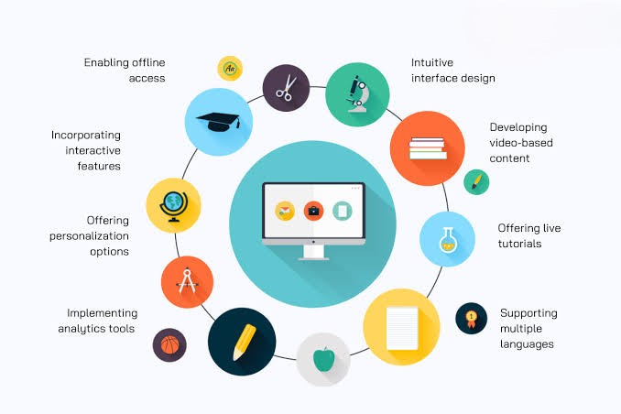

Fig.No:5 **Assignment and Quiz Creation**

**6. Testing and Evaluation**

Testing and evaluation are crucial phases in the development of an e-learning platform, ensuring that the system functions correctly, meets the needs of its users, and delivers a high-quality learning experience. These phases involve a series of activities designed to identify defects, verify functionality, and validate the system's overall effectiveness.

**6.1 Test Plan and Strategy**

A well-defined test plan and strategy is essential for effective testing and evaluation. The test plan outlines the scope, objectives, resources, and schedule for testing activities. It specifies the types of testing to be performed, the test environment, the test data, and the criteria for success. The test strategy, on the other hand, defines the overall approach to testing, including the techniques, tools, and methodologies to be used.

The test plan should cover all aspects of the e-learning platform, including its functionality, usability, performance, security, and compatibility. It should also address the different levels of testing, such as unit testing, integration testing, system testing, and user acceptance testing. Each level of testing has a specific purpose and focuses on different aspects of the system.

The test strategy should describe the testing techniques that will be used, such as black-box testing, white-box testing, and gray-box testing. Black-box testing involves testing the system from the user's perspective, without knowledge of the internal code or structure. White-box testing involves testing the internal code and structure of the system, with knowledge of its design and implementation. Gray-box testing combines elements of both black-box and white-box testing.

The test strategy should also specify the tools that will be used to support the testing process. These tools may include test management tools, test automation tools, performance testing tools, and security testing tools. The selection of appropriate tools can significantly improve the efficiency and effectiveness of the testing process.

The test environment should be representative of the production environment, including the hardware, software, and network configuration. This ensures that the system is tested under realistic conditions and that any issues that may arise in the production environment are identified during testing.

Test data is another important element of the test plan. The test data should be comprehensive and realistic, covering a wide range of scenarios and use cases. It should also include both valid and invalid data to ensure that the system handles errors and exceptions correctly.

The criteria for success, or acceptance criteria, define the conditions that must be met for the testing to be considered successful. These criteria should be clear, measurable, and specific, providing a basis for determining whether the system meets the requirements and is ready for deployment.

The test plan and strategy should be documented in a test plan document, which serves as a guide for the testing team and other stakeholders. This document should be reviewed and approved by all relevant parties before testing begins.

Regular reviews and updates of the test plan and strategy are essential to ensure that they remain relevant and effective throughout the development process. As the system evolves and new features are added, the test plan may need to be adjusted to accommodate these changes.

By developing a comprehensive and well-defined test plan and strategy, the development team can ensure that the e-learning platform is thoroughly tested and evaluated, and that it meets the required standards of quality and reliability. This investment in the early stages of the testing process can save time and resources in the long run by preventing costly defects and ensuring user satisfaction.

**6.2 Unit Testing and Integration Testing**

Unit testing and integration testing are fundamental testing techniques used to ensure the quality and reliability of an e-learning platform. Unit testing focuses on testing individual components or modules of the system in isolation, while integration testing focuses on testing the interactions between these components. Both types of testing are essential for identifying defects early in the development process and preventing them from propagating to later stages.

Unit testing involves testing the smallest testable parts of the application, such as functions, methods, or classes. The goal of unit testing is to verify that each unit of code performs its intended function correctly. Unit tests are typically written by developers and are executed frequently, often as part of the development process.

For example, in an e-learning platform, a unit test might be written to verify that a function that calculates a student's final grade is working correctly. The test would provide various inputs, such as assignment scores and quiz results, and check that the function returns the correct final grade for each scenario.

Integration testing, on the other hand, involves testing the interactions between different units or components of the system. The goal of integration testing is to verify that these components work together as expected and that they correctly exchange data and control. Integration tests are typically performed after unit testing and before system testing.

In an e-learning platform, integration testing might involve testing the interaction between the user authentication module and the course management module. The test would verify that a user can log in to the system, access the courses they are enrolled in, and that only authorized users can access certain resources.

Both unit testing and integration testing can be performed manually or using automated testing tools. Automated testing tools can significantly improve the efficiency and effectiveness of the testing process, especially for large and complex systems. These tools can automatically execute tests, compare the actual results with the expected results, and generate reports.

Test-driven development (TDD) is a development approach that emphasizes writing tests before writing the code. In TDD, developers first write a failing test, then write the code to make the test pass, and finally refactor the code to improve its quality. TDD can help to improve the design of the code, increase test coverage, and prevent defects.

Continuous integration (CI) is a development practice that involves automatically building and testing the application every time a developer commits changes to the version control system. CI can help to detect defects early, prevent integration problems, and ensure that the application is always in a working state.

Code coverage is a metric that measures the percentage of code that is executed by the tests. High code coverage indicates that the tests are thorough and that they cover most of the application's functionality. However, high code coverage does not guarantee the absence of defects, as the tests may not cover all possible scenarios or edge cases.

Documentation is essential for both unit testing and integration testing. The tests should be well-documented, with clear descriptions of the purpose of each test, the inputs used, and the expected outputs. This documentation serves as a guide for developers and testers, and it can also be used to generate test reports.

By performing thorough unit testing and integration testing, the development team can ensure that the e-learning platform is built on a solid foundation, that its components work correctly both individually and together, and that it meets the required standards of quality and reliability. This investment in early testing can save time and resources in later stages of development and prevent costly defects.

**6.3 User Acceptance Testing**

User acceptance testing (UAT) is a critical phase in the testing process of an e-learning platform. It is the final stage of testing, where the system is evaluated by the end-users to determine whether it meets their needs and expectations. UAT is performed after system testing and before the system is deployed to the production environment.

The primary goal of UAT is to validate that the e-learning platform is fit for purpose and that it satisfies the requirements specified by the stakeholders. It focuses on testing the system from the user's perspective, ensuring that it is user-friendly, functional, and meets their specific needs. UAT is not intended to find defects, but rather to confirm that the system works as expected in a real-world scenario.

UAT is typically performed by a group of representative users, who may include educators, students, and administrators. These users are selected based on their roles and their familiarity with the e-learning process. They are provided with a test environment that mimics the production environment and are asked to perform a series of tasks that represent typical use cases.

The UAT process is guided by a UAT plan, which outlines the objectives, scope, methodology, and criteria for acceptance. The UAT plan specifies the user roles, the test scenarios, the test data, and the expected results. It also defines the acceptance criteria, which are the conditions that must be met for the system to be accepted by the users.

The test scenarios are designed to cover the key functionalities of the e-learning platform, such as course creation, enrollment, content delivery, assignment submission, and communication. The users are asked to perform these tasks as they would in a real-world setting, following the steps outlined in the test scenarios.

During UAT, the users record their findings, noting any issues, errors, or deviations from the expected behavior. They also provide feedback on the system's usability, functionality, and overall satisfaction. This feedback is then reviewed by the development team, who address any issues and make necessary adjustments to the system.

The acceptance criteria are used to determine whether the system is accepted or rejected by the users. If the system meets all the acceptance criteria, it is considered to be ready for deployment. If, however, there are any critical issues or unmet criteria, the system is returned to the development team for further work.

UAT is a collaborative process that involves close interaction between the users, the development team, and other stakeholders. Regular meetings and communication are essential to ensure that the testing process is on track and that any issues are resolved in a timely manner.

Documentation is a crucial aspect of UAT. The results of the testing, including any issues, feedback, and resolutions, should be documented in a UAT report. This report serves as a record of the testing process and provides evidence that the system has been tested and validated by the users.

By conducting thorough and well-planned UAT, the development team can ensure that the e-learning platform meets the needs of its users, provides a positive learning experience, and is ready for deployment to the production environment. UAT is a critical step in the development process that helps to minimize the risk of user dissatisfaction and system failure.

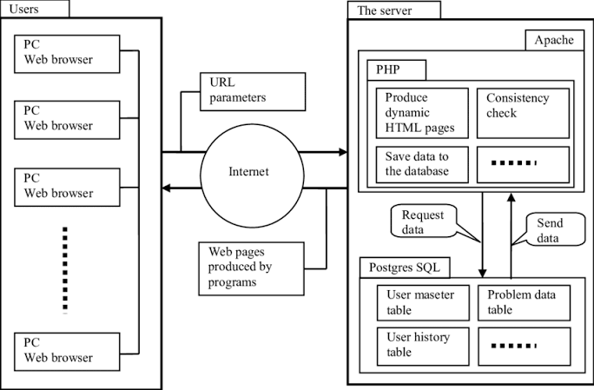

Fig.No:6 **User Acceptance Testing**

**7. Security and Performance Considerations**

Security and performance are critical considerations in the development of an e-learning platform. The platform must be designed to protect sensitive data, ensure a smooth and responsive user experience, and scale to accommodate future growth. Addressing these considerations early in the development process can prevent costly problems and ensure the long-term success of the platform.

**7.1 Data Security Measures**

Data security is paramount for an e-learning platform, as it handles sensitive information such as student records, grades, and personal data. A breach of this data can have serious consequences, including legal liabilities, reputational damage, and loss of user trust. Therefore, robust security measures must be implemented to protect against unauthorized access, use, or disclosure of data.

One of the fundamental security measures is to implement strong authentication and authorization mechanisms. This involves verifying the identity of users when they log in to the platform and controlling their access to resources based on their roles and permissions. Techniques such as strong passwords, two-factor authentication, and single sign-on can be used to enhance authentication security.

Encryption is another essential security measure. Data should be encrypted both in transit and at rest. Encryption in transit protects data as it is being transmitted between the user's browser and the server, while encryption at rest protects data that is stored on the server. Secure protocols such as HTTPS should be used for data transmission, and strong encryption algorithms should be used for data storage.

Access control is also crucial for data security. The platform should implement the principle of least privilege, which means that users should only have access to the data and resources that they need to perform their job functions. Access control lists and role-based access control can be used to enforce these restrictions.

Regular security audits and vulnerability assessments should be conducted to identify and address any security weaknesses in the platform. These audits can help to detect potential vulnerabilities, such as SQL injection, cross-site scripting, or other common web attacks. The platform should also be regularly updated with the latest security patches to protect against known vulnerabilities.

Data backup and recovery is another important aspect of data security. The platform should have a robust backup and recovery plan in place to ensure that data can be restored in case of a system failure, data loss, or other disaster. Backups should be performed regularly and stored securely, preferably in a separate location from the primary data.

Compliance with relevant data protection regulations, such as GDPR or FERPA, is also essential. These regulations impose strict requirements on how personal data is collected, used, and stored. The platform should be designed to comply with these regulations to avoid legal liabilities and maintain user trust.

Security awareness training for both developers and users is crucial. Developers should be trained on secure coding practices and common security vulnerabilities, while users should be educated on how to protect their accounts and data. This can help to reduce the risk of security breaches caused by human error.

Incident response planning is also important. The platform should have a plan in place for how to respond to a security incident, such as a data breach or a cyberattack. This plan should include procedures for containing the incident, recovering the data, and notifying the affected parties.

By implementing these data security measures, the e-learning platform can protect sensitive information, maintain user trust, and ensure the confidentiality, integrity, and availability of data.

**7.2 Performance Optimization**

Performance optimization is crucial for ensuring a smooth and responsive user experience on an e-learning platform. A slow or unresponsive platform can lead to user frustration, decreased engagement, and ultimately, a negative impact on the learning experience. Therefore, various techniques should be employed to optimize the platform's performance.

One of the key areas of performance optimization is database optimization. The database is a critical component of the platform, and its performance can significantly impact the overall system performance. Techniques such as indexing, query optimization, and database caching can be used to improve database performance.

Caching is another effective technique for improving performance. Caching involves storing frequently accessed data in memory, so that it can be retrieved quickly without having to query the database. Both server-side caching and client-side caching can be used. Server-side caching involves storing data on the server, while client-side caching involves storing data in the user's browser.

Code optimization is also essential for performance. The platform's code should be written efficiently, following best practices and avoiding unnecessary overhead. Techniques such as code minification, compression, and lazy loading can be used to reduce the amount of data that needs to be transferred between the server and the client.

Network optimization is another important aspect of performance. The platform should be designed to minimize the number of HTTP requests and the amount of data that needs to be transferred over the network. Techniques such as using a content delivery network (CDN), optimizing images, and using asynchronous loading can be used to improve network performance.

Load balancing is crucial for handling a large number of concurrent users. Load balancing involves distributing the traffic across multiple servers, so that no single server is overloaded. This can help to prevent performance bottlenecks and ensure that the platform remains responsive even during peak usage times.

Performance testing should be conducted regularly to identify any performance bottlenecks or issues. Performance testing involves simulating a large number of concurrent users and measuring the platform's response time, throughput, and other performance metrics. The results of the testing can be used to identify areas that need improvement.

Monitoring is also essential for maintaining optimal performance. The platform should be continuously monitored to detect any performance issues or anomalies. Tools such as application performance monitoring (APM) tools can be used to track various performance metrics and alert administrators to any problems.

Regular maintenance and optimization of the platform's infrastructure is also important. This includes tasks such as database maintenance, server optimization, and network optimization. These tasks can help to ensure that the platform continues to perform well over time.

By implementing these performance optimization techniques, the e-learning platform can provide a smooth, responsive, and enjoyable user experience, even under heavy load.

**7.3 Scalability and Future Enhancements**

Scalability is a critical consideration for an e-learning platform, as it needs to be able to accommodate future growth in the number of users, courses, and features. The platform should be designed to handle increasing demand without experiencing performance degradation or downtime. In addition to scalability, the platform should also be designed to accommodate future enhancements and new technologies.

Scalability can be achieved through various techniques, such as horizontal scaling, vertical scaling, and database sharding. Horizontal scaling involves adding more servers to the system, while vertical scaling involves upgrading the existing server with more resources, such as CPU, memory, or storage. Database sharding involves partitioning the database across multiple servers to distribute the load.

Cloud computing provides a flexible and scalable infrastructure for e-learning platforms. Cloud platforms such as AWS, Azure, or Google Cloud offer a wide range of services that can be used to scale the platform, such as auto-scaling, load balancing, and managed databases.

Microservices architecture is another approach that can improve scalability and maintainability. In a microservices architecture, the platform is divided into a collection of small, independent services that can be scaled and updated independently. This allows for more flexibility and resilience.

API design is crucial for both scalability and future enhancements. The platform should be designed with a well-defined API that allows for easy integration with other systems and applications. This can facilitate the addition of new features and the integration with third-party services.

For example, AI and ML can be used to provide personalized learning recommendations, automate grading, and provide intelligent tutoring. VR and AR can be used to create immersive and interactive learning experiences, such as virtual field trips or simulations.

The platform should also be designed to support new learning paradigms, such as blended learning, flipped classroom, or personalized learning. These paradigms require different features and functionalities, such as video conferencing, online collaboration tools, and adaptive assessments.

**8. Conclusion and Future Work**

The development of an e-learning platform represents a significant undertaking with the potential to transform education and make learning more accessible and effective. This section summarizes the achievements of the project, acknowledges its limitations, and outlines potential future enhancements to further improve the platform.

**8.1 Summary of Achievements**

The e-learning platform has achieved several key objectives, demonstrating its potential as a valuable tool for online education. The platform provides a comprehensive set of features and functionalities that cater to the needs of both educators and students, supporting various aspects of the learning process.

The platform's user-friendly interface and intuitive design make it easy for both educators and students to navigate and use its features. Educators can create and manage courses, upload learning materials, design assignments and quizzes, and track student progress. Students can access course content, participate in discussions, submit assignments, and receive feedback.

The platform's robust course management system enables educators to organize their courses effectively, deliver engaging content, and manage student enrollment. The system supports a variety of content types, including text, images, videos, and interactive simulations, providing a rich and dynamic learning experience.

The platform's assignment and quiz creation tools empower educators to assess student learning and provide valuable feedback. The system supports various question types and grading methods, allowing educators to design effective assessments that measure student understanding and promote learning.

The discussion forum feature fosters a sense of community and promotes active learning by providing a virtual space for students and educators to interact and share ideas. The forums facilitate meaningful conversations, encourage collaboration, and enhance the overall educational experience.

The platform's progress tracking and reporting tools provide valuable insights into student learning and course effectiveness. Educators can monitor student performance, identify areas where students may need additional support, and assess the impact of their teaching strategies. Students can track their own progress, view their grades, and receive feedback on their achievements.

The platform's multimedia support enhances the learning experience by allowing educators to integrate various media formats into their course content. This caters to diverse learning styles, increases student engagement, and makes online learning more interactive and immersive.

In conclusion, the e-learning platform has achieved its primary goals of providing a comprehensive, user-friendly, and engaging online learning environment. It offers a wide range of features and functionalities that support effective teaching and learning, and it has the potential to make a significant contribution to the field of education.

**8.2 Limitations**

Despite its achievements, the e-learning platform has some limitations that may affect its functionality and user experience. These limitations should be addressed in future development efforts to further improve the platform and enhance its capabilities.

One limitation is the platform's dependence on a stable internet connection. Online learning relies heavily on internet connectivity, and users in areas with poor or unreliable internet access may experience difficulties using the platform. This can create a digital divide and limit the accessibility of online education for some students.

Another limitation is the potential for technical issues and downtime. Like any software system, the e-learning platform is susceptible to technical problems, such as server errors, database issues, or software bugs. These issues can disrupt the learning process and cause frustration for both educators and students.

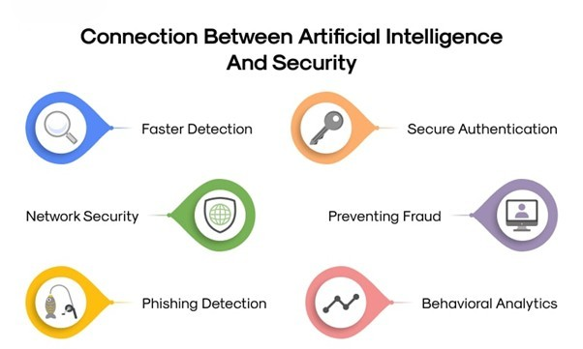

Fig.No:7 **Conclusion and Future Work**

**9.Refernace**

1. **Django Documentation:** The official documentation for the Django web framework. <https://docs.djangoproject.com/en/4.2/>

* This is the primary source for information on Django, covering everything from installation and setup to advanced features and best practices.

1. **Python Documentation:** The official Python documentation. <https://docs.python.org/3/>
   * This resource provides comprehensive information about the Python programming language, including tutorials, library references, and language specifications.
2. **HTML Standard:** The official specification for the Hypertext Markup Language (HTML). <https://html.spec.whatwg.org/>
   * This document defines the structure and semantics of HTML, the standard markup language for creating web pages.
3. **CSS Standard:** The official specification for Cascading Style Sheets (CSS). <https://www.w3.org/Style/CSS/>
   * This resource provides information on CSS, a stylesheet language used for controlling the presentation of web pages.
4. **JavaScript Documentation:** Information about JavaScript from Mozilla. <https://developer.mozilla.org/en-US/docs/Web/JavaScript>
   * MDN provides detailed guides and references for JavaScript, a versatile scripting language for web development.
5. **Database Design - Entity-Relationship Model:** Peter Chen's original paper on the Entity-Relationship Model
   * Chen, P. P. (1976). The entity-relationship model—toward a unified view of data. ACM transactions on database systems, 1(1), 9-36.
   * This is a foundational paper in database design, explaining a fundamental approach to modeling data.
6. **Web Content Accessibility Guidelines (WCAG):** The official guidelines for making web content more accessible. <https://www.w3.org/WAI/standards-guidelines/wcag/>
   * WCAG provides recommendations for making web content more accessible to people with disabilities.
7. **OAuth 2.0:** The specification for the OAuth 2.0 authorization framework. <https://oauth.net/2/>
   * OAuth 2.0 is a widely used protocol for authorization, allowing users to grant limited access to their resources without exposing their credentials.

**Output**

Step 1:login page

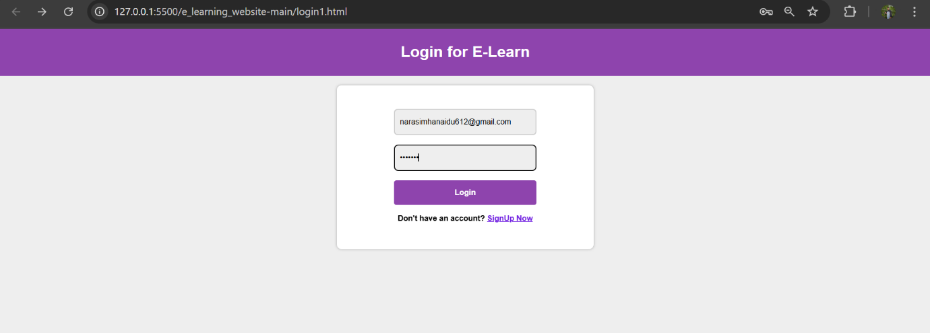

Step 2 Home of e learning website

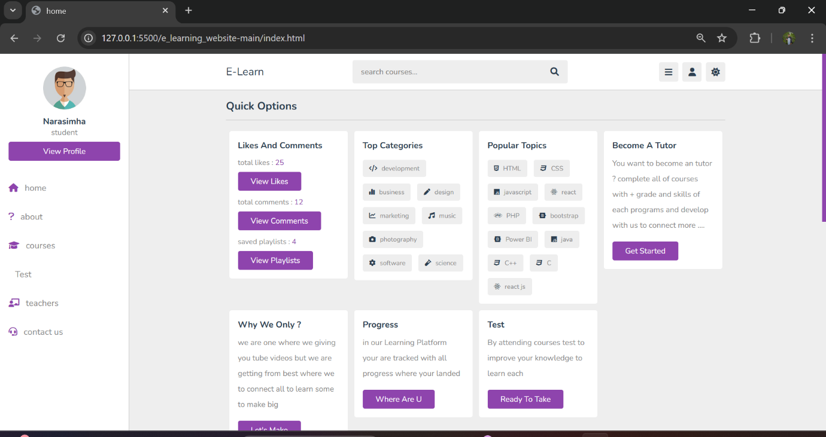

Step 3: courses page

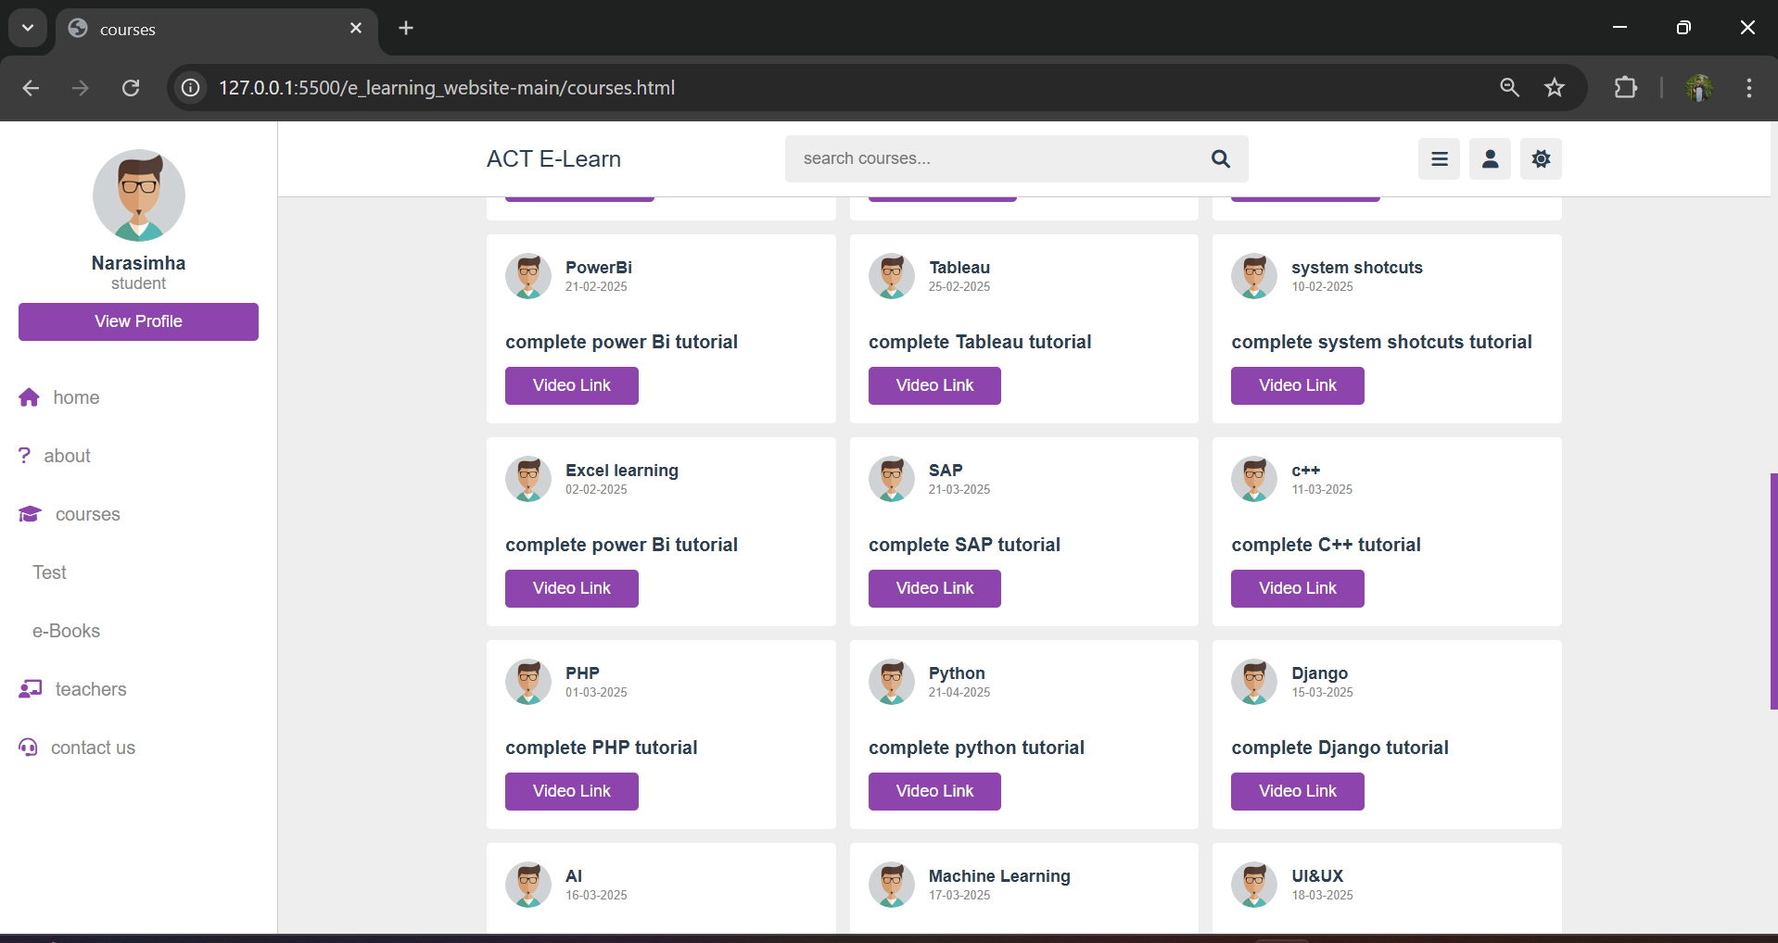

Step :4 contact details

